I am attaching the pipelines I have used for the technical design
- Overview of the Design Pipeline

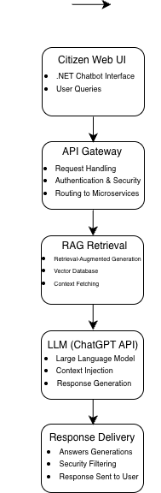
- Data Preparation and Engineering Stages

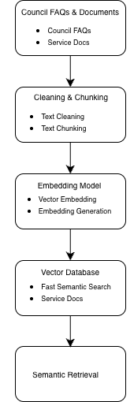
- Frontend Layer

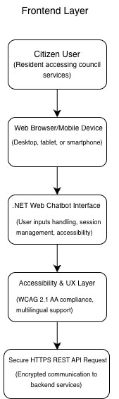

- Backend Layer

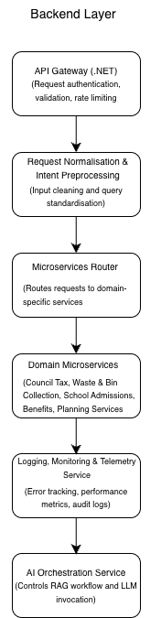

- AI Services Layer

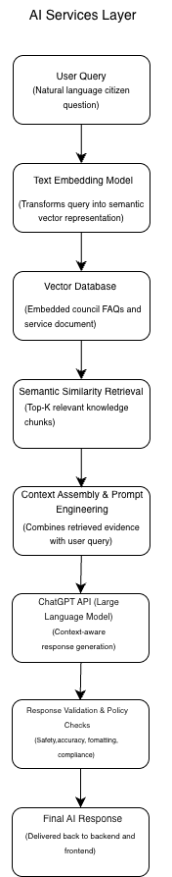

- Deployment & Infrastructure Layer

